# Special Instructions to Run for OpenMP

For OpenMp and OpenMP_SolutionB

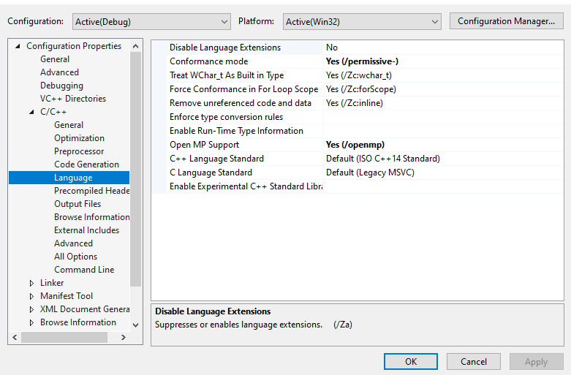

For OpenMP_SolutionC, there is 1 extra step. Which is to add “/openmp:experimental %(AdditionalOptions)” to enable SIMD support

